

**Faculty of engineering - Shoubra Benha University**

# Research Article / Research Project / Literature Review

in fulfillment of the requirements of

|  |  |
| --- | --- |
| **Department** | **Engineering Mathematics and Physics** |
| **Division** | **----------** |
| **Academic Year** | **2019 – 2020 Preparatory** |
| **Course name** | **Computer** |
| **Course code** | **ECE001** |

**Title: -**

**Programming languages**

By:

|  |  |  |  |
| --- | --- | --- | --- |
|  | Name | Edu mail | B.N |
| 1 | **Hazem Esaam Hassan edris** | [**Hazem195303@feng.bu.edu.eg**](mailto:Hazem195303@feng.bu.edu.eg) | **273** |

## Approved by:

|  |  |
| --- | --- |
| Examiners committee | Signature |
| Dr. Ahmed Bayoumi |  |
| Dr. Shady ELmashad |  |
| Dr. Abdelhamid Attaby |  |

**Application Brief**

A programming language is a very important thing, that is because this language that is used for computer or any computing device, it is vocabulary used to set an instruction to perform specific tasks on a computer, and it divided into two levels, the first called "low-level" it is a machine language that uses binary ('1' and '0')  code that a computer  execute very fast without using any translator or interpreter program, and it very hard to read and understand because the low-level language is not meant to human readable, the second type or level called high-level are much simple this language is the one whose used by programmer to write a code, High-level languages are designed to be easy to read and understand, the example of the high-level language is a lot like: BASIC, C, C++, Java.

There is a lot of language that is used in programming language it is approximately 700 programming languages like C, C#, HTML, Java, JavaScript, Ruby, SQL, Swift, Python, PHP, Basic, SGML, Rust, Etc.

The programming language has a lot of uses and applications in our daily life like: internet and web development, database development, AI development, Game development, Script development, etc.

# Screenshots

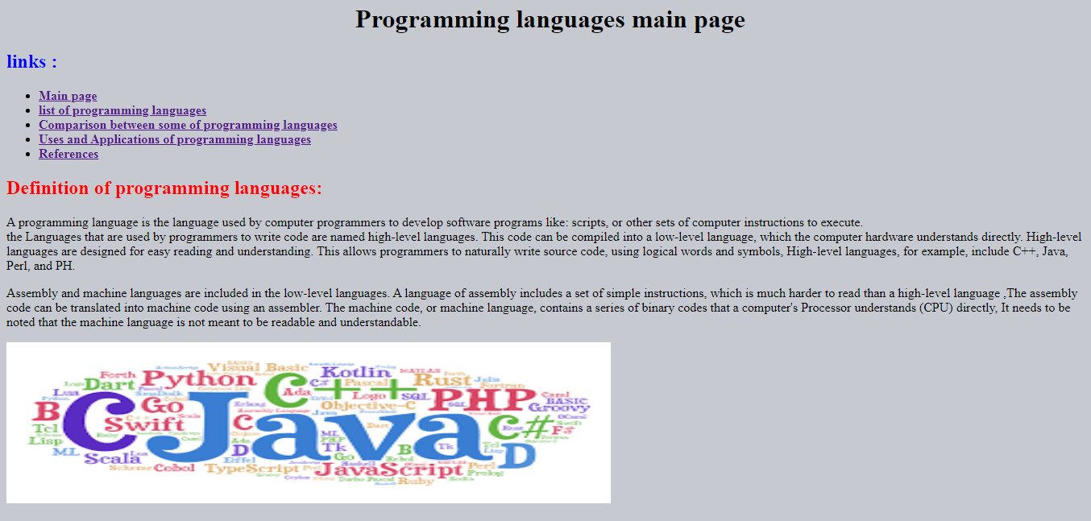

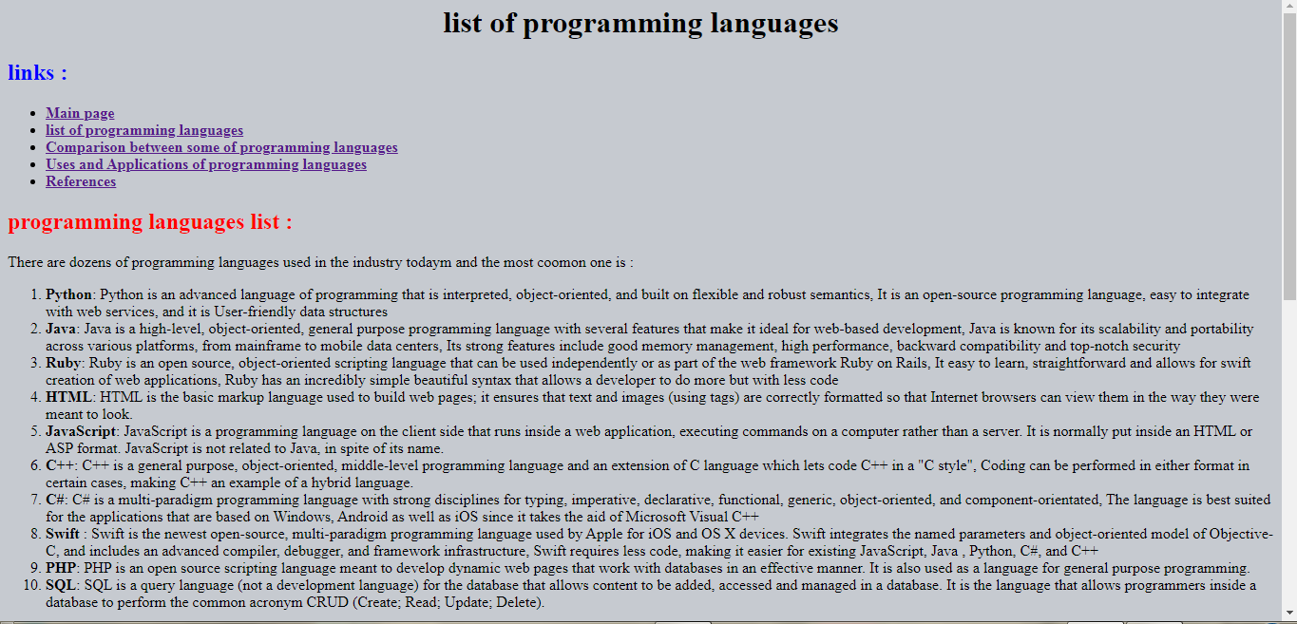

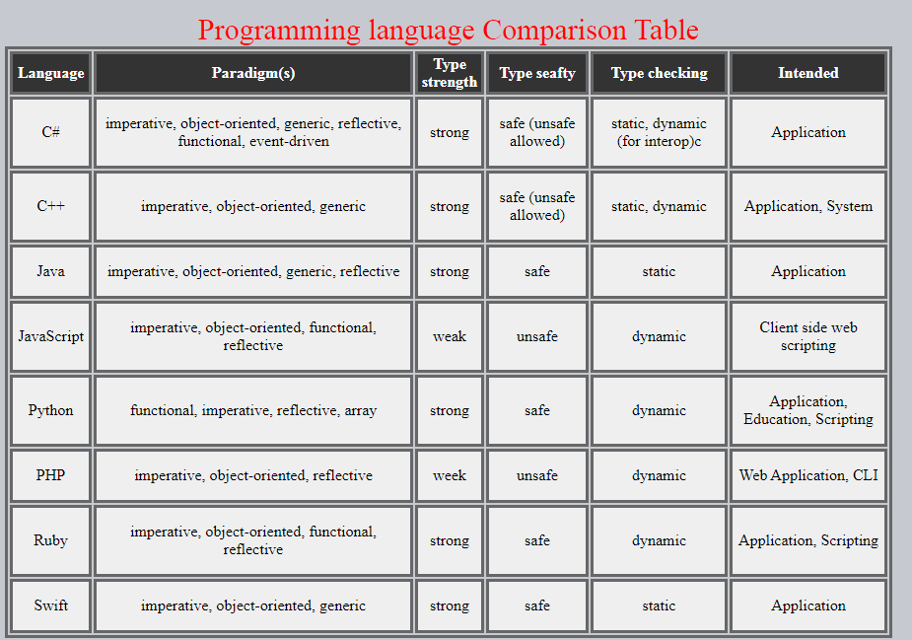

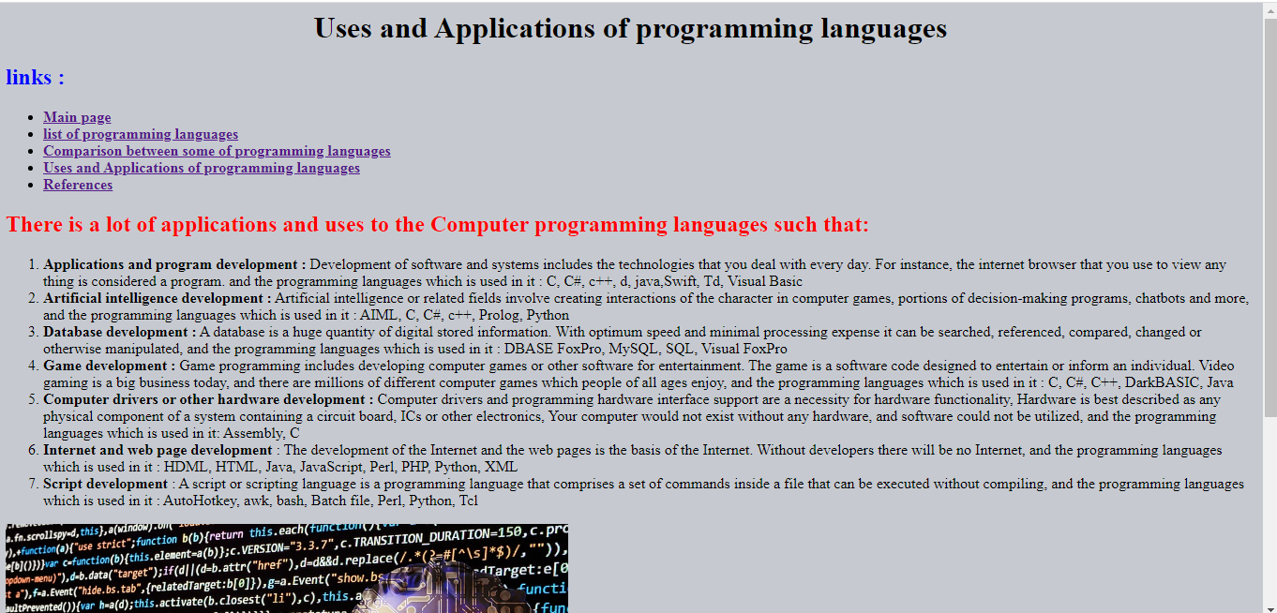

**Source code**

